18 July 2023, Rudolf

**Running Streamlit on MacBook Pro, using the latest code available in the main branch of the GitHub repository PolarizedLightFieldMicroscopy/forward-model**

I processed guv3_GT.h5 and guv4_GT.h5 with and without noise applied to the data and generated using BirefrObjectGeneratorJuly2023.nb. For reconstructions, I used default parameter settings.

**Optical settings:**

Number of microlenses: 31 or 11

Pixels per microlens: 17

Number of voxels per microlens (supersampling): 1

Magnification: 60

NA of objective: 1.2

Wavelength of light: 0.55 µm

camera pixel size: 6.5 µm

refractive index of medium: water n=1.35

**guv3_GT.h5 ->guvBir[radius=6.5, membrane thickness=1, Δn=0.01]**

Number of microlenses: 31

Number of voxels per microlens (supersampling): 1

Volume shape: [15, 61, 61]

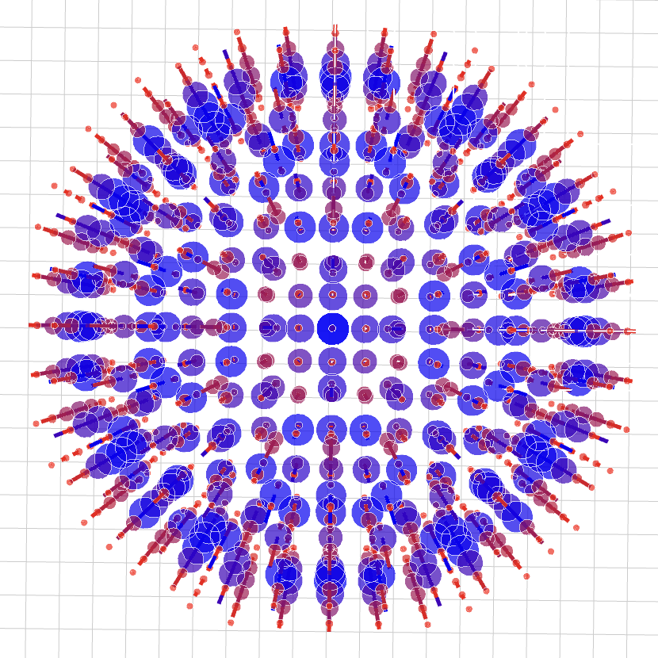 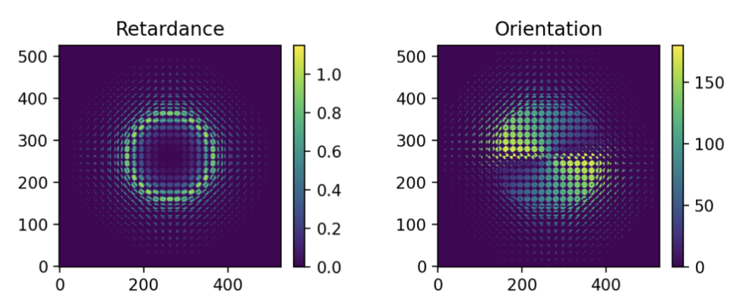

What is the reason and the recipe for creating the reduced initial volume that is populated with random data?

**Reconstruction, using internal random initial volume:**

Number of iterations: 1

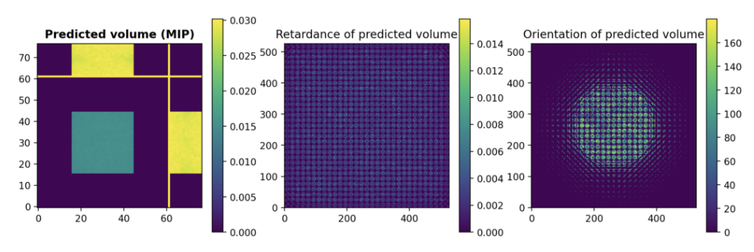

**Reconstruction, using external random2.h5 as initial volume:**

Number of iterations: 1

What is the reason for the circular pattern in the initial orientation light field image?

**guv3_GT.h5 ->guvBir[radius=6.5, membrane thickness=1, Δn=0.01]**

Number of microlenses: 31

Number of voxels per microlens (supersampling): 1

**Reconstruction, using internal random initial volume:**

Number of iterations: 50

Number of iterations: 200

Volume also in file guv3_Recon1Iter200.h5

**Reconstruction, using external random2.h5 as initial volume:**

Number of iterations: 50

The images on the next page were generated using the same volume but assigning 3 voxels per microlens diameter. The reconstruction quickly confines birefringent voxels to the nominal focus plane.

These are pretty good reconstructions, which are only achieved with 1 as the number of voxels per microlens (supersampling)

**guv3_GT.h5**

Number of microlenses: 11

Number of voxels per microlens (supersampling): 3

**Reconstruction, using internal random initial volume:**

Number of iterations: 1

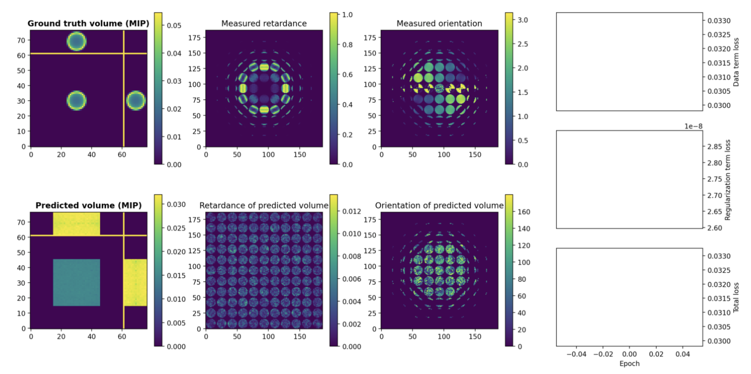

Volume also in file guv3_Recon2Iter1.h5

Number of iterations: 4

Number of iterations: 50

Number of iterations: 200

Volume also in file guv3_Recon2Iter200.h5

**guv3_GT.h5**

Number of microlenses: 11

Number of voxels per microlens (supersampling): 3

**Reconstruction, using external random2.h5 as initial volume:**

Number of iterations: 1

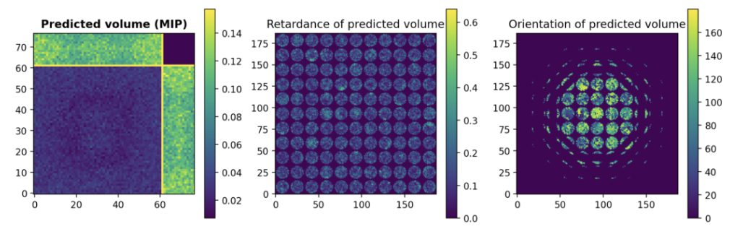

Volume also in file guv3_Recon3Iter1.h5

Number of iterations: 50

Volume also in file guv3_Recon3Iter50.h5

random2.h5 has the same size as the guv3_GT.h5 volume, {15, 61, 61} and every voxel has a random birefringence and optic axis orientation.

**guv4_GT.h5 -> guvBir[radius=9.5, membrane thickness=1, Δn=0.01]**

Number of microlenses: 51

Number of voxels per microlens (supersampling): 1

Volume shape: [23, 91, 91]

**Reconstruction, using internal random initial volume:**

Number of iterations: 1

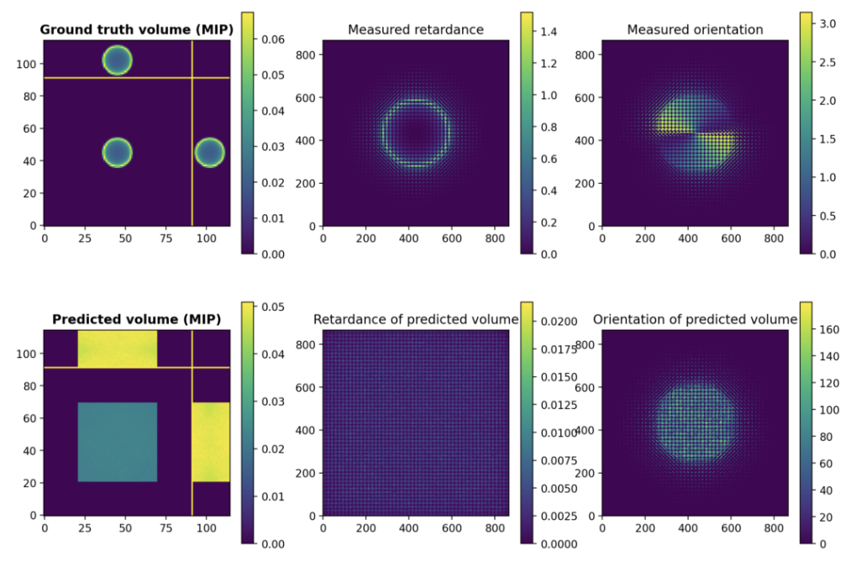

Number of iterations: 50

Volume also in file guv4_Recon3Iter50.h5

As before, 1 as the number of voxels per microlens gives a pretty good reconstruction. But for supersample = 3, the reconstruction confines the birefringence to the nominal focus plane.

**guv4N2_GT.h5-> guvBir[radius=9.5, membrane thickness=1, Δn=0.01]**

**with noise added to GUV and volume data**

Number of microlenses: 51

Number of voxels per microlens (supersampling): 1

Volume shape: [23, 91, 91]

**Reconstruction, using internal random initial volume:**

Number of iterations: 1

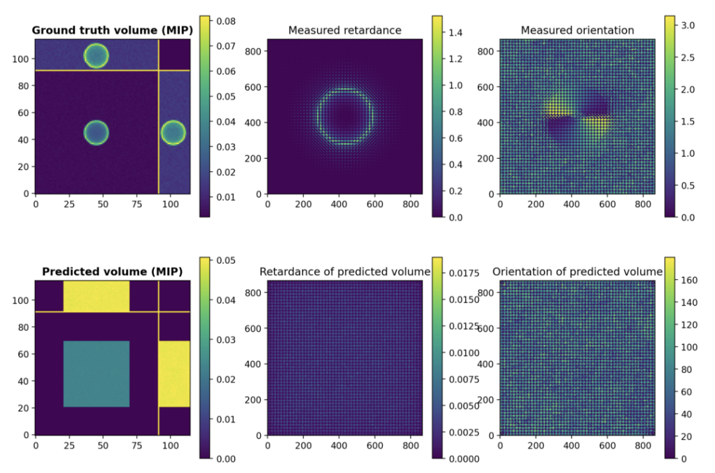

Note, the orientation data are not confined here to a central circle, as observed on page 1 and 5

Number of iterations: 50

Volume also in file guv4N2_Recon1Iter50.h5

**Reconstruction, using external guv4N1_GT.h5 as initial volume:**

Number of iterations: 1

Volume also in file guv4N2_Recon2Iter1.h5

Number of iterations: 2

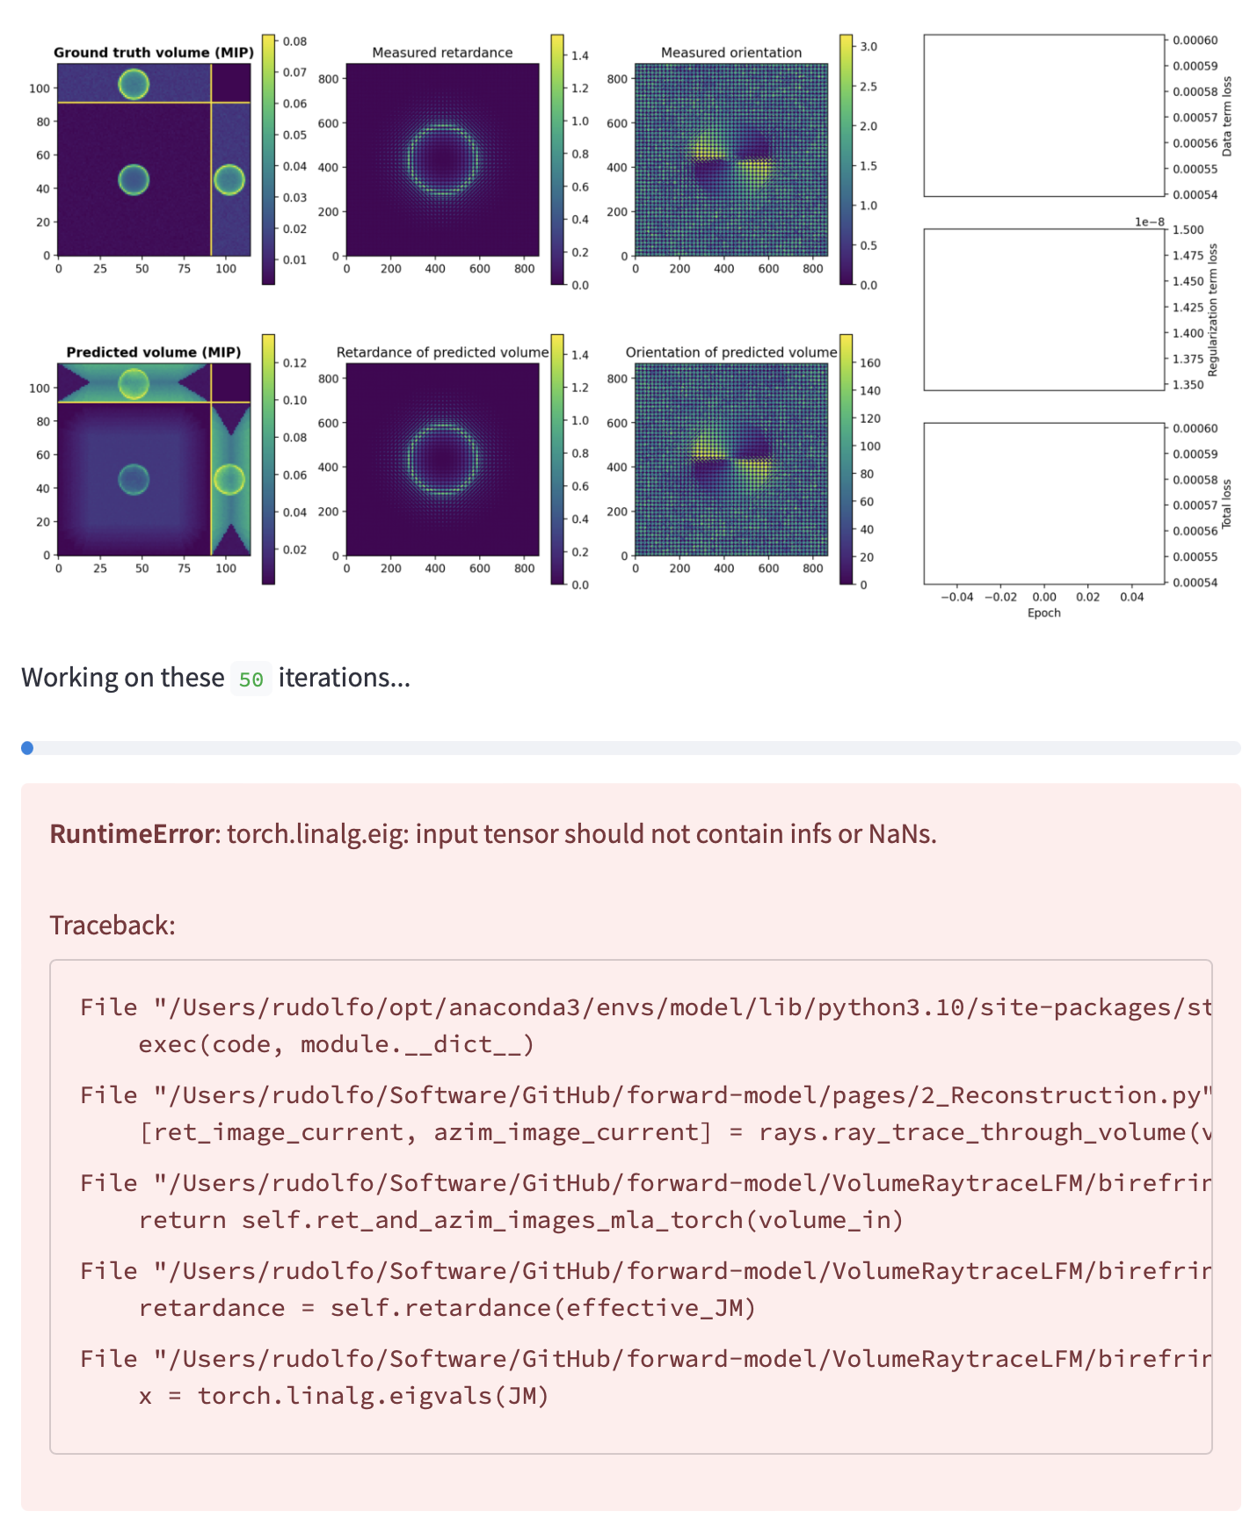

This error message consistently appears at the second iteration step, when I use a volume with a birefringent object as the initial volume for the reconstruction.

Please fix this